International Civil Aviation Organization
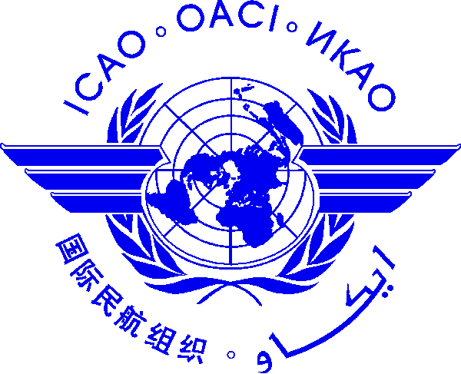 |  | Aerodrome Inspection and Audit Course for Civil Aviation Inspectors  12 - 16 November 2012, Bangkok, Thailand.  Workshop on State functions and Responsibilities regarding the Assessment, Measurement and Reporting of Runway Surface Conditions  19 – 22 November 2012, Bangkok, Thailand

Nomination Form [please type or print]

State/ Organization
Name | Title |  |  | Family name (capitals) |  |  | First name |  |  | Middle initial
 | Mr/Dr/Ms
Status |  |  | Principle Delegate |  |  | Delegate |  |  | Advisor
Official Position
Mailing Address
Telephone (office)
Fax
e-mail (1)
e-mail (2)
Hotel in Bangkok

Note 1: Participants are expected to make their own hotel/visa arrangements.
Note 2: All meeting material will be provided in soft copy (electronic) to participants.

Date ..........................……….... Signature ………….....………...
After completing, please send to: ICAO Regional Office for Asia and Pacific, P.O. Box 11, Samyaek Ladprao, Bangkok 10901, Thailand
Fax: 66 (2) 537 8199 or E-mail: icao_apac@bangkok.icao.int by 2 November 2012.

